Expert Systems

Fundamentals of Expert Systems
http://zimmer.csufresno.edu/~sasanr/Teaching-Material/MIS/ES/Expert%20Systems-Handouts.pdf

Sample interview/dialog between the user and the expert system:

User: I am experiencing a problem with my printer.
System: What kind of a problem?

User: The lights keep blinking.
System: What kind of printer do you have?

User: HP DeskJet 920C.
System: Do all lights keep blinking?

User: No; the power light blinks but the cartridge & resume lights are off.
System: Does this happen when the printer is processing a print job?

User: No
System: What you need to do is: ……………………………

All knowledge that CAN be articulated (explicit knowledge) MAY be stated in rules of the form: IF X, THEN Y
Knowledge-Base
(Domain Rules)
IF
<Acrobat Reader 6 does not display large images>
THEN
<click Edit/Preferences/Page Display and check the box labeled "Display large images">

- symptoms
- conditions
- circumstances

- prescription
- action
- solution
How are Knowledge-Based Systems different from Expert Systems?

Knowledge-Based Systems: Less Structured

Knowledge-Base
(Free-Form Text)

search
knowledge
response

Expert/
Specialist
User

Expert Systems: More Structured

Knowledge-Base
Domain Rules
“IF …, THEN …”
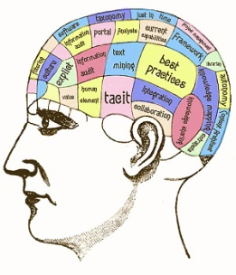
User
Inter-face
interview knowledge rules
advice

User
Expert/
Specialist
Knowledge Engineer

Inference Engine
Logic Rules

IF X, THEN Y
IF Y, THEN Z
IF X, THEN Z

